Reading skills progression – RWI & VIPERS

At St. Philip’s we aim to ensure that all of our children will become fluent readers with a well rounded vocabulary and comprehension skills that can apply in their lives as well as further education. To enable this, all children will read with an adult in their class at least once a week. Children that are pupil premium eligible or bottom 20% readers (or both) will read with an adult in their class at least twice a week.

Children in EYFS and KS1 on the RWI programme will have a fully phonologically decodable book (their RWI book/picture discussion book) to read as a home reader and with an adult in school as well as a “chosen” book called a “a book to share” that may be more challenging and needs to be read with family at home to enjoy a story or non-fiction depending on the child’s interest. Fluency skills are developed through modelling and practised reading 1:1, in small groups and in whole class reading lessons.
In KS2, children have 2 books to read with an adult and at home. One book is fully at their reading level based on reading age assessments using Salford Reading Assessments for children off the RWI programme. The second book is of their choice but at a slightly more challenging level, again “a book to share”. We use the CLPE reading tracker to identify the types of readers we have and their next steps in developing fluency.

To develop comprehension at St. Philip’s we use the VIPERS reading skills from KS1 – KS2.

Vipers (created by Rob Smith, The Literacy Shed) is a range of reading prompts based on the 2016 reading
content domains found in the National Curriculum Test Framework documents for KS1 and KS2. VIPERS is an acronym to aid the recall of the 6 reading domains as part of the UK’s reading curriculum. They are the key areas which we feel children need to know and understand in order to improve their comprehension of texts.

VIPERS stand for:
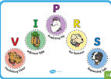
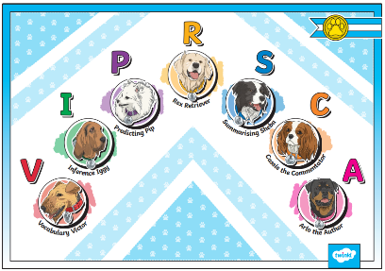

In KS1, ‘Explain’; is not one of the content domains, rather it asks children why they have come to a certain conclusion, to explain their preferences, thoughts and opinions about a text.
In KS2, the Explain section covers the additional content domains of 2F, 2G and 2H which are not present in KS1.

The 6 domains focus on the comprehension aspect of reading and not the mechanics: decoding, fluency, prosody etc. As such, VIPERS is not a reading scheme but rather a method of ensuring that teachers ask, and students are familiar with, a range of questions. They allow the teacher to track the type of questions asked and the children’s responses to these which allows for targeted questioning afterwards.

EYFS
Children in EYFS follow the Read Write Inc phonics programme. Children in Reception will use their picture discussion to promote communication and language with a focus on vocabulary. They are introduced to the VIPERS characters in the Summer term, one at a time, during whole class story time one of the skills/characters will be talked about with the children and targeted questioning is based on this skill/character during the story session.

KS1
In Key Stage One children reading skills are taught and practised using the VIPERS during whole class reading sessions. This is done 30 minutes daily. They are introduced and reintroduced each new academic year and each skill is focussed on individually using extracts initially and then applied to a class novel. Skills are then utilised in combinations as the year progresses. The teaching sequence involves a focus on an area of the class novel and immersing children in a hook, targeted and guided discussion and vocabulary exploration. Throughout the week, more independent activities are planned around the focus area of the novel that has been hooked in at the start of the week. This cycle may be longer or shorter depending on the length and complexity of the focus area. Children that require adaptive teaching will work on one key skill during a cycle of lessons and use scaffolding and aural and oral methods of independent working. This could include different text work being selected for independent reading work where a child cannot access independent reading of the class focus text i.e. phonics level focussed texts e.g. pink books or ditties.

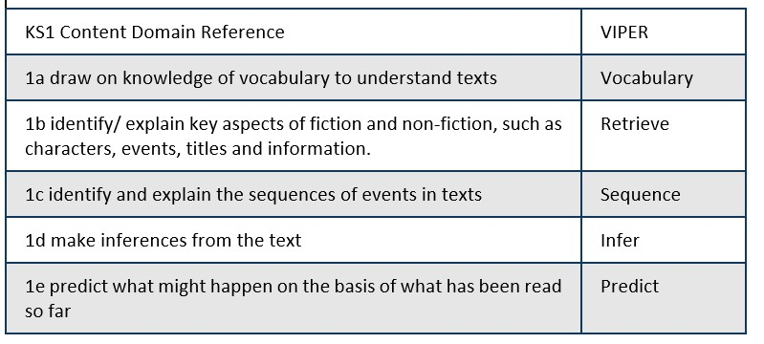

KS1 reading dog images support understanding of the vipers.

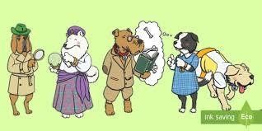

KS2
In Key Stage Two children reading skills are taught and practised using VIPERS during whole class reading sessions. This is done 30 minutes daily. They are introduced and reintroduced each new academic year and each skill is focussed on individually using extracts initially and then applied to a class novel. Skills are then utilised in combinations as the year progresses. The teaching sequence involves a focus on an area of the class novel and immersing children in a hook, targeted and guided discussion and vocabulary exploration. Throughout the week, more independent activities are planned around the focus area of the novel that has been hooked in at the start of the week. This cycle may be longer or shorter depending on the length and complexity of the focus area. Where children have failed to use the skill focussed on, keep up catch up sessions working with an adult following the lessons will ensure that all children can achieve. Children that require adaptive teaching will work on one key skill during each lesson and use scaffolding and may use aural and oral methods of independent working. This could include different text work being selected for independent reading work where a child cannot access independent reading of the class focus text i.e. shorter extracts or a text with a lower Lexile count.

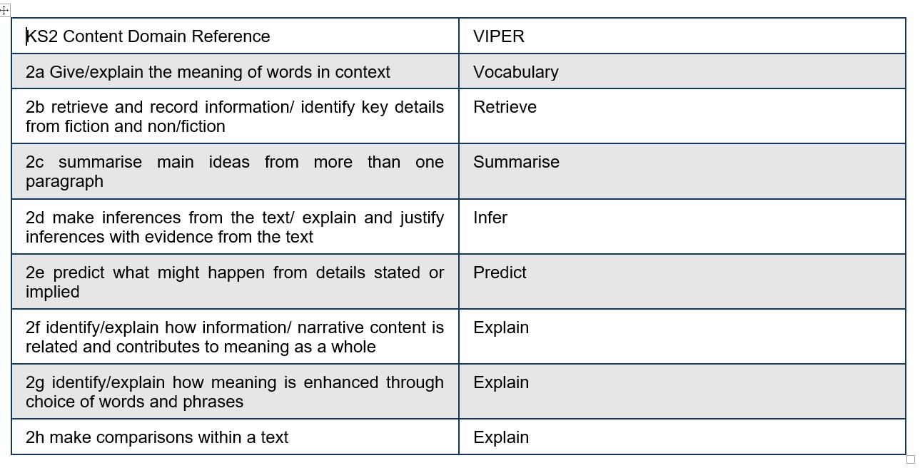

KS2 images to support understanding of the VIPERSCA
Focus Reading Skills Progression
Year Groups | YEAR 1 | YEAR 2 | YEAR 3 | YEAR 4 | YEAR 5 | YEAR 6
Terms
AUTUMN 1 | Retrieval Skill -  Teaching and Consolidation  Vocabulary taught as come across in class texts | Retrieval Skill -  Teaching and Consolidation  Vocabulary taught as come across in class texts | Retrieval Skill -  Teaching and Consolidation  Vocabulary taught as come across in class texts | Retrieval Skill -  Teaching and Consolidation  Vocabulary taught as come across in class texts | Retrieval Skill -  Teaching and Consolidation  Vocabulary taught as come across in class texts | Retrieval Skill -  Teaching and Consolidation  Vocabulary taught as come across in class texts
AUTUMN 2 | Inference Skill – Teaching and Consolidation  Vocabulary taught as come across in class texts | Inference Skill – Teaching and Consolidation  Vocabulary taught as come across in class texts | Inference Skill – Teaching and Consolidation  Embedding of retrieval skill throughout lessons.  Vocabulary taught as come across in class texts | Inference Skill – Teaching and Consolidation  Embedding of retrieval skill throughout lessons.  Vocabulary taught as come across in class texts | Inference Skill – Teaching and Consolidation  Embedding of retrieval skill throughout lessons.  Vocabulary taught as come across in class texts | Inference Skill – Teaching and Consolidation  Embedding of retrieval skill throughout lessons.  Vocabulary taught as come across in class texts
SPRING 1 | Sequencing – Teaching and Consolidation  Retrieval and inference skills embedded throughout lessons  Vocabulary taught as come across in class texts | Sequencing – Teaching and Consolidation  Retrieval and inference skills embedded throughout lessons  Vocabulary taught as come across in class texts | Summarising – Teaching and Consolidation  Embedding of retrieval and inference skills throughout lessons.  Vocabulary taught as come across in class texts | Summarising – Teaching and Consolidation  Embedding of retrieval and inference skills throughout lessons.  Vocabulary taught as come across in class texts | Summarising – Teaching and Consolidation  Embedding of retrieval and inference skills throughout lessons.  Vocabulary taught as come across in class texts | Summarising – Teaching and Consolidation  Embedding of retrieval and inference skills throughout lessons.  Vocabulary taught as come across in class texts
 | YEAR 1 | YEAR 2 | YEAR 3 | YEAR 4 | YEAR 5 | YEAR 6
SPRING 2 | Prediction – Teaching and Consolidation  Retrieval and inference skills embedded throughout lessons  Vocabulary taught as come across in class texts | Prediction – Teaching and Consolidation  Retrieval and inference skills embedded throughout lessons  Vocabulary taught as come across in class texts | Prediction – Teaching and Consolidation  Retrieval, inference and summarising skills embedded throughout lessons  Vocabulary taught as come across in class texts | Prediction – Teaching and Consolidation  Retrieval, inference and summarising skills embedded throughout lessons  Vocabulary taught as come across in class texts | Prediction – Teaching and Consolidation  Retrieval, inference and summarising skills embedded throughout lessons  Vocabulary taught as come across in class texts | Prediction – Teaching and Consolidation  Retrieval, inference and summarising skills embedded throughout lessons  Vocabulary taught as come across in class texts
SUMMER 1 | Consolidation and embedding of a mixture of all VIPERS skills  Vocabulary taught as come across in class texts | Consolidation and embedding of a mixture of all VIPERS skills  Vocabulary taught as come across in class texts | Comparing and Contrasting – Teaching and Consolidation  Retrieval, inference, summarising and predicting skills embedded throughout lessons  Vocabulary taught as come across in class texts | Comparing and Contrasting – Teaching and Consolidation  Retrieval, inference, summarising and predicting skills embedded throughout lessons  Vocabulary taught as come across in class texts | Comparing and Contrasting – Teaching and Consolidation  Retrieval, inference, summarising and predicting skills embedded throughout lessons  Vocabulary taught as come across in class texts | Comparing and Contrasting – Teaching and Consolidation  Retrieval, inference, summarising and predicting skills embedded throughout lessons  Vocabulary taught as come across in class texts
SUMMER 2 | Consolidation and embedding of a mixture of all VIPERS skills – focus on weakest areas  Vocabulary taught as come across in class texts | Consolidation and embedding of a mixture of all VIPERS skills – focus on weakest areas  Vocabulary taught as come across in class texts | How meaning is enhanced through choice words and phrases in combination with vocabulary taught as come across in class texts  Consolidating and embedding all VIPERSCA skills | How meaning is enhanced through choice words and phrases in combination with vocabulary taught as come across in class texts  Consolidating and embedding all VIPERSCA skills | How meaning is enhanced through choice words and phrases in combination with vocabulary taught as come across in class texts  Consolidating and embedding all VIPERSCA skills | How meaning is enhanced through choice words and phrases in combination with vocabulary taught as come across in class texts  Consolidating and embedding all VIPERSCA skills

Vocabulary
Year 1 | Year 2 | Year 3 | Year 4 | Year 5 | Year 6
Understand and recognise simple recurring literary language in stories and poetry | Understand and recognise simple recurring literary language in stories and poetry | Understand what he/she reads independently by checking that the text makes sense to him/her, discussing his/her understanding of words | Maintain positive attitudes to reading and understanding of what he/she reads by using dictionaries to check the meaning of words that he/she has read | Understand what he/she reads by checking that the book makes sense to him/her, discussing his/her understanding and exploring the meaning of words in context | Understand what he/she reads by identifying how language, structure and presentation contribute to meaning
Discuss and clarifying the meanings of words, linking new meanings to known vocabulary | Discuss and clarifying the meanings of words, linking new meanings to known vocabulary | Understand what he/she reads independently by identifying how language, structure, and presentation contribute to meaning to include paragraphs, headings, sub-headings, inverted commas to punctuate speech | Understand what he/she reads independently by checking that the text makes sense to him/her, discussing his/her understanding and explaining the meaning of words in context | Discuss and evaluate how authors use language, including figurative language, considering the impact on the reader | Discuss and evaluate how authors use language, including figurative language, considering the impact on the reader
Maintain positive attitudes to reading and understanding of what he/she reads by discussing words and phrases that capture the reader's interest and
imagination
 |  |  | Understand what he/she reads independently by identifying how language, structure, and presentation contribute to meaning, to include: paragraphs, use of pronouns for cohesion, inverted commas for speech, apostrophes to mark possession, fronted adverbials
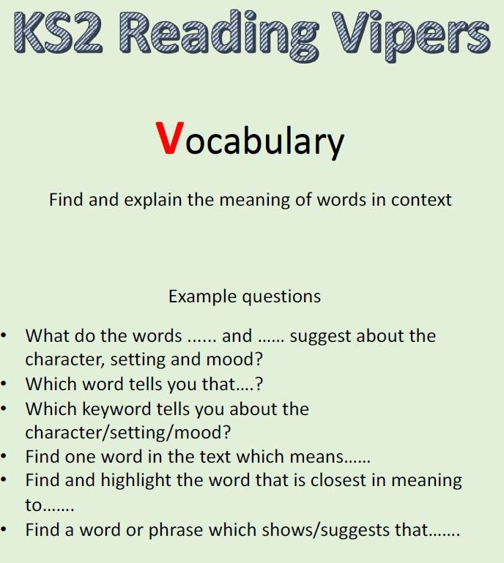
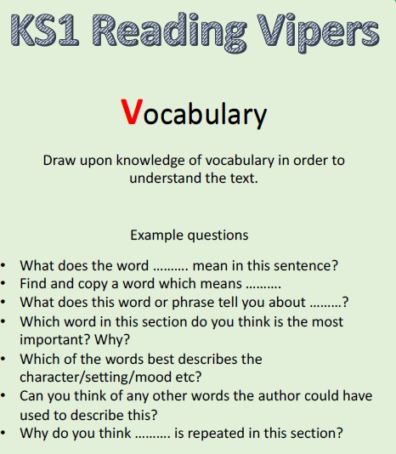

Inference
Year 1 | Year 2 | Year 3 | Year 4 | Year 5 | Year 6
Make simple inferences based on pictures and short extracts of texts around character’s feelings and motivations | Make inferences on the basis of what is being said and done | Understand what he/she reads independently by drawing inferences such as inferring characters' feelings, thoughts and motives from their actions, and justifying inferences with evidence | Understand what he/she reads independently by drawing inferences such as inferring characters' feelings, thoughts and motives from their actions, and justifying inferences with evidence clearly taken from the text | Understand what he/she reads by drawing inferences such as inferring characters' feelings, thoughts and motives from their actions, and justifying inferences with evidence | Draw inferences such as inferring characters’ feelings, thoughts and motives from their actions, and justifying inferences with evidence
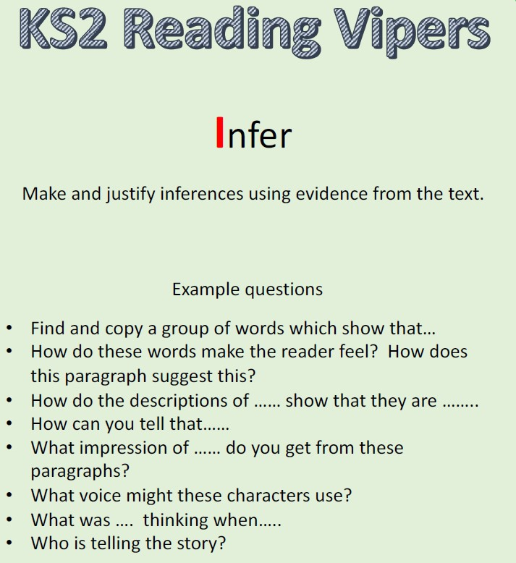
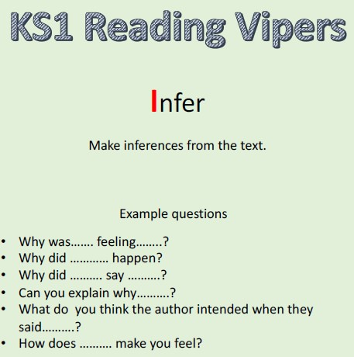

Prediction
Year 1 | Year 2 | Year 3 | Year 4 | Year 5 | Year 6
Make plausible predictions about what might happen on the basis of what has been read so far sometimes prompted and guided by adult led discussions | Make plausible predictions about what might happen on the basis of what has been read so far | Understand what he/she reads independently by predicting what might happen from details stated | Understand what he/she reads independently by predicting what might happen from details stated and implied | Understand what he/she reads in increasingly complex texts by predicting what might happen from details stated and implied | Predict what might happen from details stated and implied
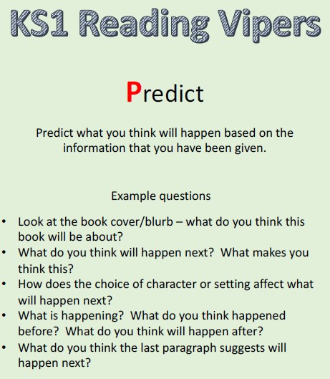
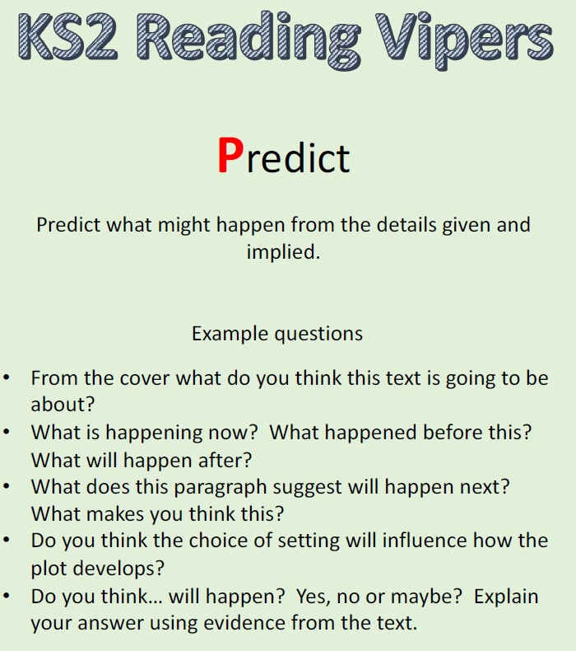

Explain
Year 1 | Year 2 | Year 3 | Year 4 | Year 5 | Year 6
Can state at least 2 key events that happen in what they have read | Explain what has happened so far in what he/she has read | Checking that the text makes sense to them, discussing their understanding and explaining the meaning of words in context | Checking that the text makes sense to them, discussing their understanding and explaining the meaning of words in context | Maintain positive attitudes to reading and understanding of what he/she reads by making comparisons within a book | Explain and discuss his/her understanding of what he/she has read, including through formal presentations and debates, maintaining a focus on the topic and using notes where necessary
Identifying how language, structure, and presentation
contribute to meaning

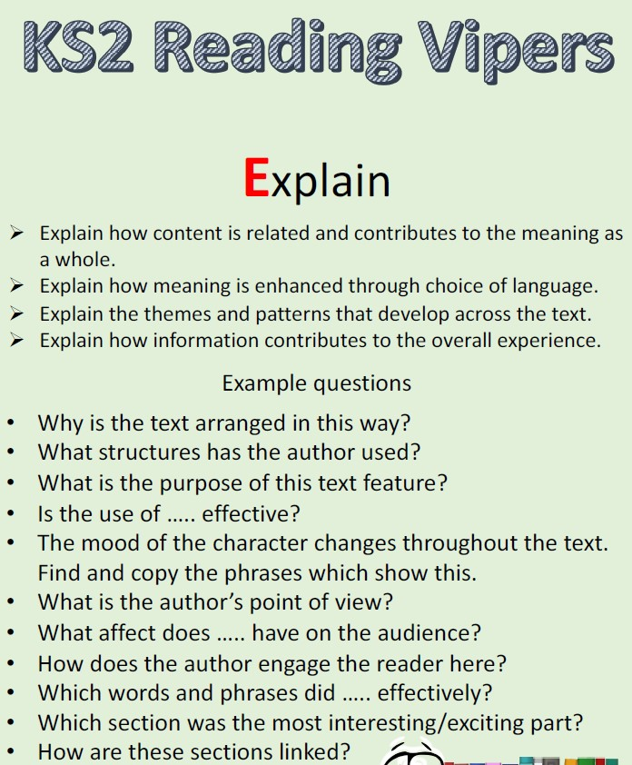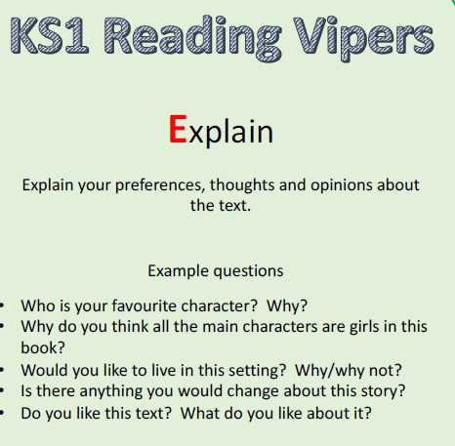

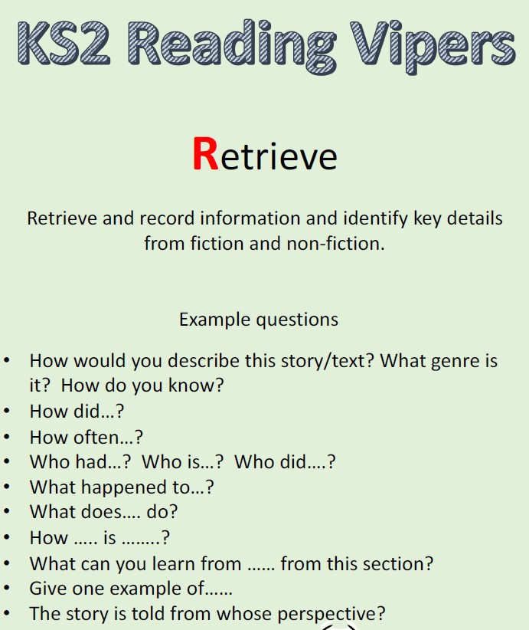
Retrieval
Year 1 | Year 2 | Year 3 | Year 4 | Year 5 | Year 6
Answering and asking questions  Use fastest finger to find the answers in the text | Answering and asking questions  Underline, circle or highlight answers in what they have read | Understand what he/she reads independently by asking questions to improve his/her understanding of a text | Retrieve and record information from non-fiction over a wide range of subjects  Highlight answers in what they have read | Understand what he/she reads by asking questions to improve his/her understanding of complex texts | Understand what he/she reads by asking questions to improve his/her understanding of complex texts
 |  | Retrieve and record information from non-fiction  Highlight answers in what they have read | Understand what he/she reads independently by asking questions to improve his/her understanding of  text with increasing complexity | Retrieve, record and present information from non-fiction  Highlight answers in what they have read | Ask questions to improve their understanding  Highlight answers in what they have read  Retrieve, record and present information from non-fiction

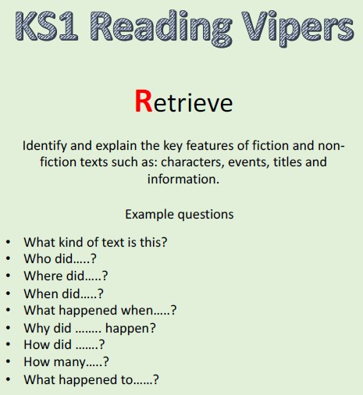

Sequence/Summarise
Year 1 | Year 2 | Year 3 | Year 4 | Year 5 | Year 6
Can state what happened first, middle and last in what they have read | Discussing the sequence of events in books and how items of information are related | Understand what he/she reads independently by identifying main ideas drawn from within one paragraph and summarise these | Understand what he/she reads independently by identifying main ideas drawn from more than one paragraph and summarise these | Summarise main ideas from more than one paragraph, identifying key details which support these. | Understand what he/she reads by summarising the main ideas drawn from more than one paragraph, identifying key details that support the main ideas and using quotations for illustration
